Femoracetabular Impingement (FAI)

Femoracetabular impingement, FAI for short, is a condition in which excess bone grows on one or both of the bones that unite to form the hip joint. Due to the excess bone growth at the hip joint, the bones do not fit together well and therefore, flexion of the hip joint causes the bones to bump into one another. When the bones rub against each other, it can cause pain in the individual and damage to the joint.

There are two types of femoracetabular impingement, CAM type and pincer type. CAM type of impingement is when there is excess bone growth on the head of the femur. Pincer type of impingement is when there is excess bone growth along the rim of the acetabulum. Both types of impingement can cause damage and tearing of the labrum, which is the cartilage that is present at the edge of the acetabulum.

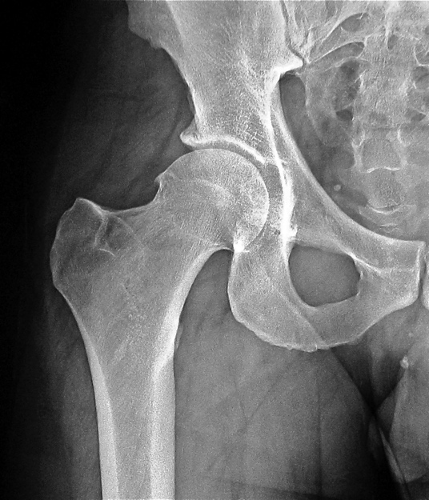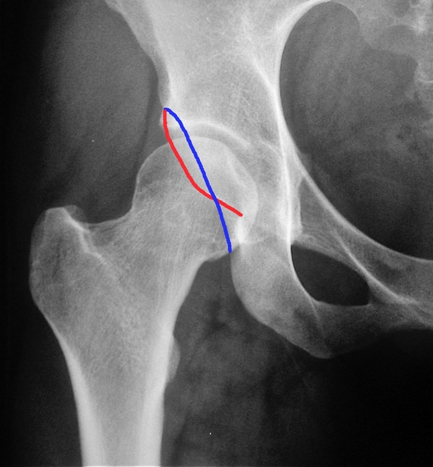
CAM Type Impingement Pincer Type Impingement

Femoracetabular impingement typically presents as pain in the groin, however, pain can occur along the lateral aspect of the hip joint and into the gluteal region as well. Pain is often exacerbated by sitting, particularly when the knees are higher than hips and deep squatting. FAI is diagnosed by an x-ray, however, an MRI is often ordered to evaluate for a labral tear and to assess the articular cartilage to help determine whether an individual is a candidate for hip arthroscopy.

Conservative treatment for femoracetabular impingement includes activity modification, anti-inflammatory medications (ibuprofen or Aleve), rest, stretching and applying ice or heat to the affected hip. A course of supervised physical may provide some benefit and is often tried before considering surgical intervention.
Hip arthroscopy is a minimally invasive surgical procedure that can help correct FAI and repair damage to the labrum. During hip arthroscopy, two to three very small incisions are made in the hip joint and a small camera called an arthroscope is inserted to view the inside of the joint. Instruments are inserted through the small incisions and are used to remove excess bone from the joint and allow improved mobility of the hip. If the labrum is torn or damaged, it can be repaired or resected. The risks of hip arthroscopy include potential risk of blood clot, infection, injury to an artery or nerve, adverse reaction to the anesthetic and the possibility that hip arthroscopy will not adequately alleviate symptoms.

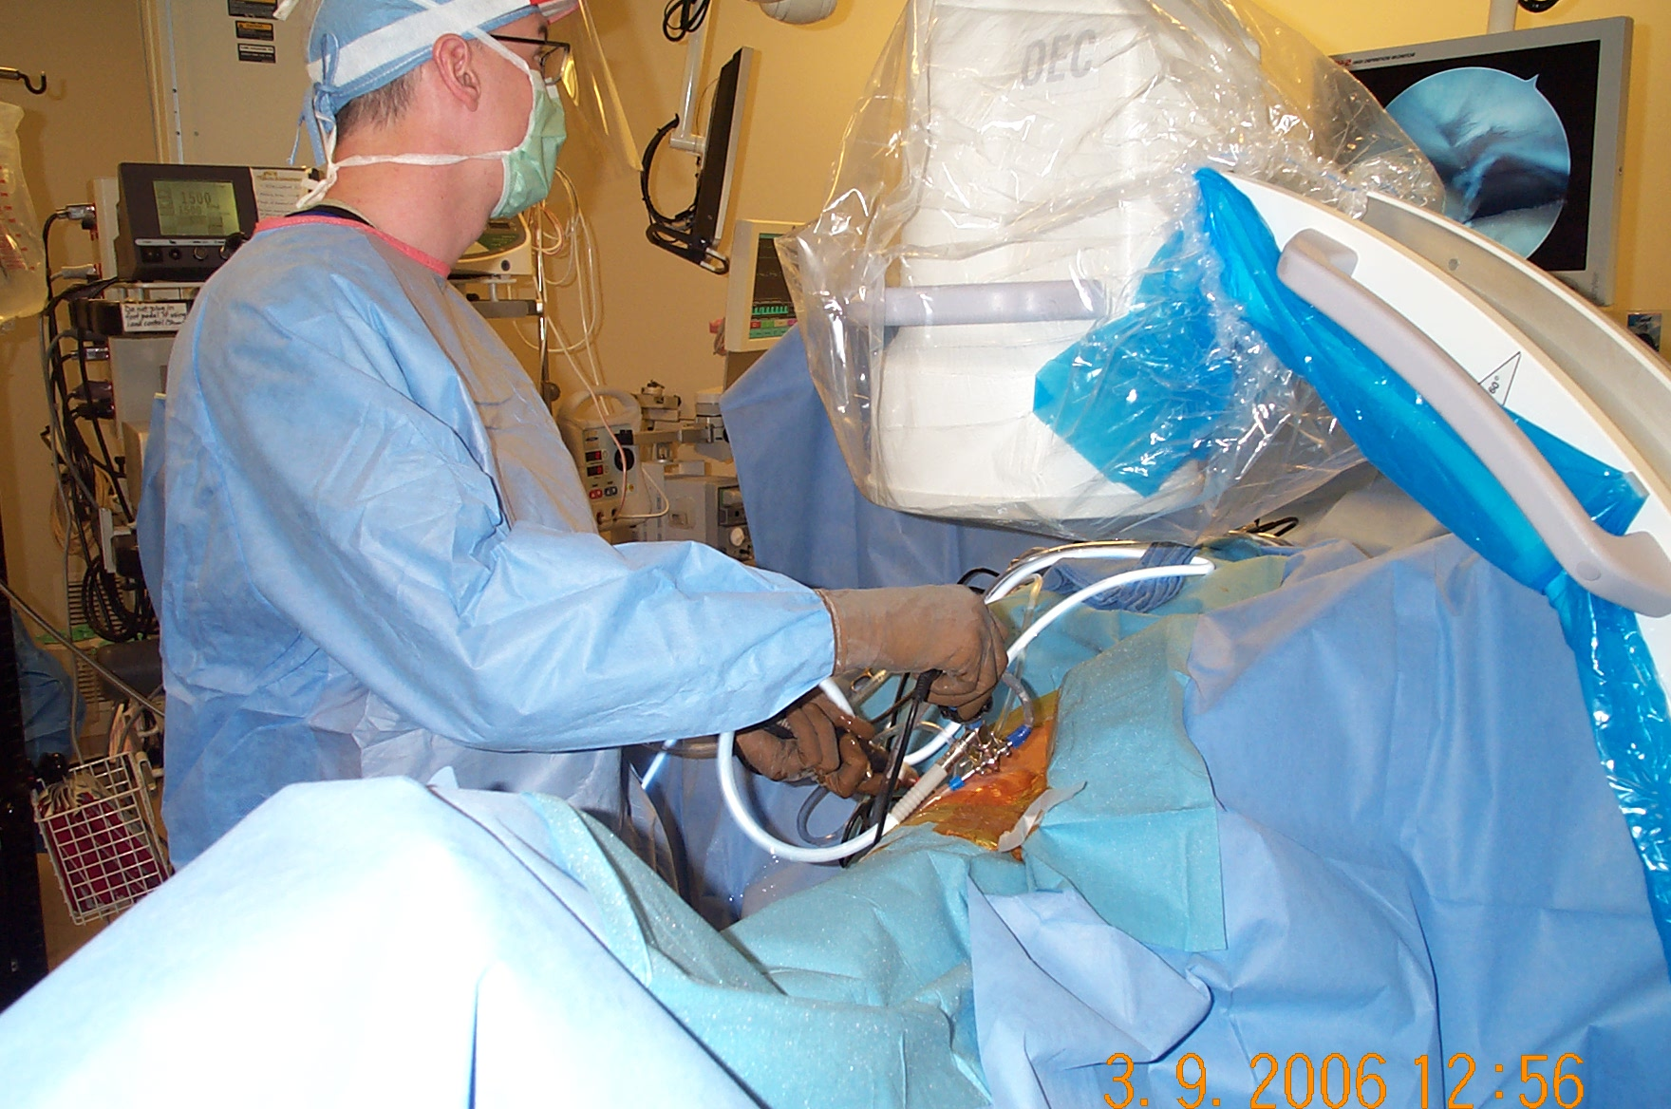
Here is an image of Dr. Stewart performing hip arthroscopy.

Hip arthroscopy is an outpatient procedure and therefore, patients go home the same day as their surgery. Patients will require someone to drive them home from their surgery and will likely need help for the first 1-2 days following their procedure. Our patients begin outpatient physical therapy the day after their surgery and we encourage our patients to go to physical therapy 2-3 times per week for several weeks following hip arthroscopy. All of our patients take naproxen twice daily after surgery to reduce the risk of excess bone growth at the surgical site, called heterotopic ossification. We also put our patients on aspirin to prevent the risk of developing a blood clot. Generally, our patients use crutches for the first few weeks after surgery. Depending on the type of femoracetabular impingement present and the exact procedure performed, some patients are able to bear weight immediately following the surgery, however, others are expected to be 20% weight bearing on the affected extremity for the first two weeks postop. Patients will be instructed on any weight bearing restrictions prior to being discharged from the hospital after their surgery.

After hip arthroscopy, patients are able to return to light duty work, such as sit down duty, 2-4 weeks after their surgery. Generally, patients are able to return to heavy duty work 4-6 weeks postoperatively. However, every patient recovers at a different pace and therefore, return to work will be discussed at your first postop visit which occurs 10-14 days after surgery.

